Wickham Park Surgery News.
A news-letter from the Patients Participation Group.
Issue No 1 January 2019
This is the first (and hopefully not the last) of a quarterly news-letter with information about the Group and its purpose, news of changes within the practice be it physical, staffing or something mundane like a lick of paint.
The practice has a responsibility under its GP contract to have a PPG. The group will consist of patients and practice representatives who come together to discuss the work of the practice and identify any areas for improvement, this can be via discussions with fellow patients or from the community in general.
For the benefit of the many new patients we start with a brief resume of the existing members of staff.

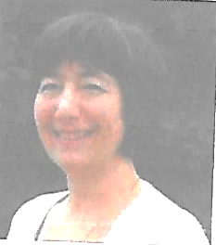
Dr Donya Young GP
I Have been involved with this practice since I first came here as a general practice trainee fresh from working at Bromley Hospital. I began my career as a GP here and will probably end it here too. Many of you have helped me grow and develop as a GP watching me as a young mother and wife and sharing your knowledge and experience with me. When I first started here General Practice was a different place, this was a single handed practice with slightly under 2000 patients. I joined as a partner when changes made by Margaret Thatcher made some local practices close, so we grew and continue to do so. We are now 5300 patients strong and have six doctors working in the practice.
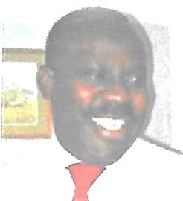
Dr Adelaja Mustapha GP
Qualified College of Medicine University of Ibadan, Nigeria 1986
Member Royal College of Obstetricians and Gynaecologist 1996
Member Royal College of GP 2003
GP partner since 2002
Dr Mustapha worked as an Obstetrician in Cornwall, London and Wales, moving into General Practice in 2001. He worked in a group practice in Conwy before joining this practice in 2002 He is married with three children and likes reading and travelling.

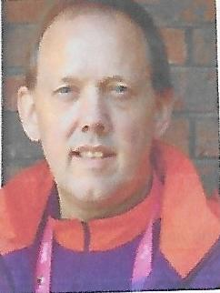
Dr Matthew Young GP
I have worked at Wickham Park Surgery as a salaried GP for 6 years, and have been a GP for nearly 30 years and have worked in various practices in Bromley. While working as a part time GP I have worked in other roles in particular specialising in treating patients who misuse alcohol and other substances. I also work for NHS England appraising other doctors. In the practice I have an interest in alcohol and substance misuse and prescribing issues. I also treat patients with a very specific form of dizziness called BPPV with the Epley manoeuvre. During the London Olympics I worked as a volunteer medical officer which was great fun. Outside of the surgery I am a big Arsenal fan(These gooners hide everywhere) and attend matches regularly. I also enjoy road cycling which some of you know. Yes I am a MAMIL. I have even persuaded my wife to take up cycling, but none of the other practice staff.
(For those who are not into Medical Acronyms or what I call Alphabet soup when I’m being polite, BPPV is Benign Paroxysmal Positional Vertigo, where specific head movements can cause vertigo and dizziness. Ed)

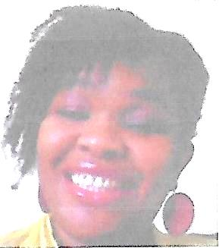
Dr Chinyere (Chi-Chi) Ekhator
Dr Ekhator works part time at the practice and is a GP Appraiser for NHS England. She completed her medical training at St George’s hospital Medical School London before joining MRCGP in 2008. She also has experience of working in Paediatric Medicine and has attained Membership of the Royal College Paediatrics and Child Health. She has a keen interest in teaching and maintains links with St Georges Medical School as an examiner. Outside of work, she enjoys and travelling.

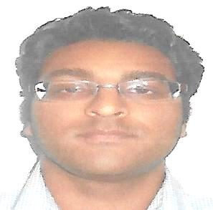
Dr Sunjesh Vaja GP
Trained at UCL medical School and qualified in 2011worked in a number of hospitals including St Georges Tooting, before entering and completing general practice training in Worcester. He is working part time at the surgery and developing interests in diabetes and genetics.

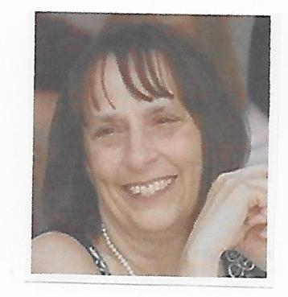
June Rees- Practice Nurse
She has been with the practice for over 20 years, she qualified at Mayday Hospital in 1977, she then went on to train as district nurse and later qualified as a Nurse Specialist Practitioner in General Practice Nursing. She qualified as a nurse practitioner at London South Bank University in 2008 and has completed the independent nurse prescribing course. She has an interest in asthma, diabetes and coronary heart disease.

Patricia Reid- Practice Nurse
She has worked in primary care since 2005 and has a vast hospital knowledge that enhances her role with us. She does childhood and travel immunisations, removal of stitches, dressings and monitoring of hypertensive patients.

Staff Changes
Shushma Leidig the Practice Manager at the last PPG meeting has left the surgery for personal reasons, although Shushma was only with the surgery for a short time, she was very sad to leave the role. She wishes to thank you all for support and input whilst she was with us.
Stephanie Douch – Stephanie has taken over the position of Practice Manager. Stephanie was the Reception Manager before taking on this role. She started working for the NHS in 2008 as a receptionist and has been with the surgery since 2013, she has undertaken a wide variety of tasks and administration duties including secretarial work before taking the Practice Manager position recently.

As all those of you that are regulars at the flu clinic know, the tea, coffee and biscuits are on the house, but any donations are always gratefully received and are added to the money from the sale of Christmas cards, the money goes each year to a charity supported by Dr Young, Freedom from Torture. The practice has received a very nice letter from FFT thanking all staff and patients for the donation of £320 and wishing everybody a Merry Christmas and a happy New Year.

DNA Appointments:

There were 286 DNA’d appointments in the last quarter.

Appointments booked in the last quarter:

Online patient access – 208
Via Reception - 7’312

I would like to keep the news-letter informative, local, interesting and reasonably light-hearted, but I need articles from anybody, staff or patients who have interesting or unusual hobbies or pastimes. Or anything that others would find of interest, do any of you walk regularly for your health? I know there is a group in Shirley and there are several around Bromley, is there one more local, would anybody be prepared to start and run one? (or should that be walk one).

Don’t forget, a news-letter needs your input
The next PPG Meeting is Monday 11th February and an email will be sent out shortly confirming time and venue.

Contact the Editor at alan.holbrow@blueyonder.co.uk

